Original article
DOI: https://doi.org/10.46768/racp.v0i0.195

Perfusion of methylene blue in ex-vivo colectomy specimens to increase lymph node harvesting
Javier Chinelli,¹ Adrián Medina,² Florencia Sarries,³ Virginia Irigoyen,³ Emilia Moreira,³ Viviana Escobar,⁴ Valentina Porro,⁴ Elisa Laca,⁴ Gustavo Rodríguez⁵

Surgical Clinic 2, and Department of Pathological Anatomy, Hospital Maciel, Montevideo, Uruguay y Corporación Médica de Canelones (COMECA), Canelones, Uruguay.

¹Adjunct Professor of Surgery
² Assistant Surgeon
³ Surgery Resident
⁴ Pathologist
⁵ Full Professor of Surgery, Chief of Surgery

The authors declare no conflicts of interest.Javier Chinelli
jchinelli01@gmail.com
Received: December 2021. Approved: February 2022.

Javier Chinelli: 0000-0002-3387-7365
Adrián Medina: 0000-0002-4930-9995
Florencia Sarries: 0000-0002-4753-0805
Virginia Irigoyen: 0000-0003-0884-6628
Emilia Moreira: 0000-0002-9300-9981
Viviana Escobar: 0000-0003-2381-697X
Valentina Porro: 0000-0001-6803-6120
Elisa Laca: 0000-0001-6215-2059
Gustavo Rodríguez: 0000-0003-3465-8364

ABSTRACT
Introduction: Colon cancer prognosis is related to the number of surgically removed lymph-nodes. The number of harvested lymph-nodes varies according to patient, tumor, surgeon and pathologist-related factors.
Aim:To assess the efficacy of ex-vivo intra-arterial methylene-blue (MB) perfusion of specimens after curative colon cancer surgery, to improve the number of harvestedlymph-nodes.
Design: Cohort, multi-centric, comparative study. A prospective study group (MB) was compared with a retrospective control group.
Material and Methods: Seventy-six patients were included, 29 in the study group (MB) and 47 in the control group. Demographics, tumor stage, tumor site, specimen length and type of resection were assessed. Lymph-node count was the primary outcome.
Results: Median number of harvested lymph-nodes was 18 and 13 in the MB and control group, respectively (p=0,033).
Conclusion: MB perfusion improved the median number of lymph-node count, as shown in the literature. We validated the efficacy of this technique, which is simple, low-cost and easy to perform.
Key words: Methylene-blue; Ex-vivo Intra-arterial Perfusion; Colectomy; Lymph-node Harvest

INTRODUCTION
The oncologic prognosis of colon cancer after curative resection is determined by several factors. Probably one of the most important is the status of the lymph nodes in the resection sample. Another well established by West et al.,¹ is the integrity of the mesocolon; however, it is not routinely reported in our setting. Lymph node involvement (stage III according to the UICC TNM classification),² has two fundamental implications: prognosis and treatment. Regarding prognosis, the 5-year survival of stage III patients is 60%.³From a therapeutic point of view, lymph node involvement implies the need for adjuvant treatment. For correct staging, an adequate number of lymph nodes must be obtained in the resection specimen, but there is no absolute consensus on the optimal number to comply with this precept. In 2007, the National Quality Forum established a number of 12 or more lymph nodes removed as the quality standard for an oncologic colectomy.⁴
Although there are techniques that can increase the number of lymph nodes removed in a surgical specimen, such as fat clearance, they usually involve longer time, additional cost and risk of toxicity.⁵ In 2008, Märkl et al.⁶ demonstrated the usefulness of ex-vivo intra-arterial methylene blue (MB) injection for the identification of lymph nodes in the surgical specimen. In 2012, Frasson et al.⁷ also obtained favorable results with the application of this technique, which has the advantage of being low cost and easily reproducible.
This study has 2 objectives:
a) To assess the usefulness of MB perfusion in specimens of ex-vivo oncologic colectomy, to facilitate lymph node harvesting.
b) To assess the quality of the resection, taking into account 2 indicators: the number of lymph nodes obtained and the integrity of the mesocolon.

MATERIAL AND METHODS
This is an experimental, multicenter, ambispective study with a prospective study arm and a retrospective control group. Data were obtained from the medical record file of the control group and a prospective registry database was designed for the study group.
Two care centers participated, the Surgical Clinic 2 of the Hospital Maciel and the Corporación Médica de Canelones.
Inclusion criteria: patients operated on for colon adenocarcinoma (including tumors of the rectosigmoid junction) electively and with curative intent. In this group, intra-arterial ex-vivo perfusion of the surgical specimen was performed fresh, before fixation in formalin. Those patients who underwent emergency surgery with palliative intent and those with tumors below the rectosigmoid junction were excluded.

Technique
The artery of the pedicle corresponding to the segment of the removed colon is cannulated at its origin with a 20G intravenous catheter, injecting 15 ml of MB diluted (2 ml) in saline solution (13 ml) (Fig. 1). In the event that the specimen includes more than one colonic segment, the procedure is repeated on the other pedicle(s). It is considered satisfactory when the serosa of the organ stains homogeneously (Fig. 2). Once the procedure is completed, the specimen is fixed in formalin. The pathology study was performed by 3 pathologists following the protocol of the College of American Pathologists (2020).⁸
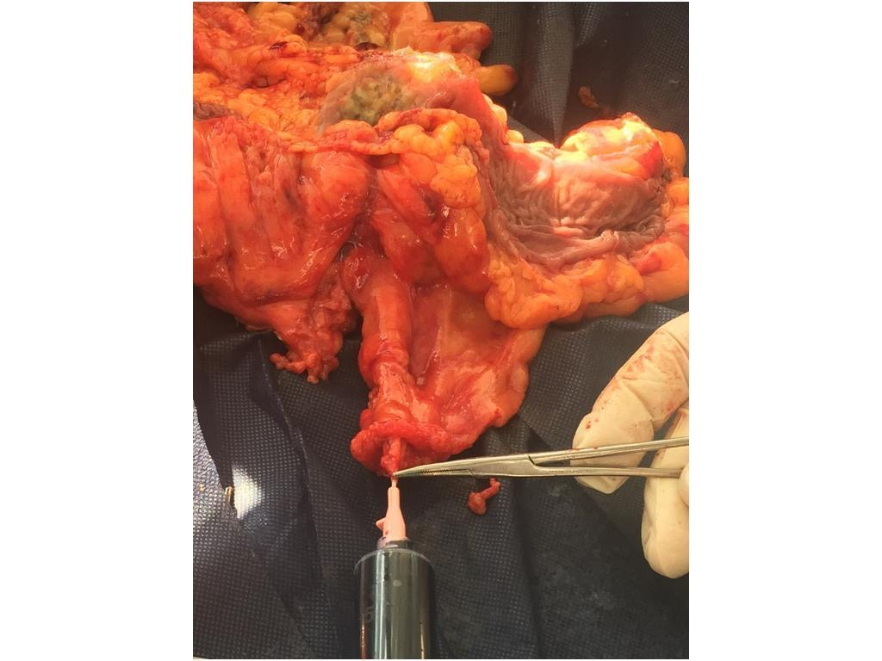
Figure 1. Methylene blue injection technique.

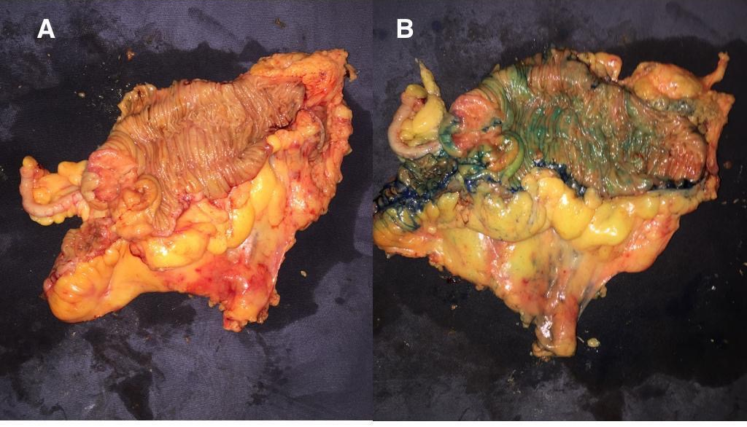
Figure 2. Surgical specimen before (A) and after (B) methylene blue injection.

A retrospective control group was formed with patients operated on in Surgical Clinic 2, who met the inclusion criteria. For each case, age (years), sex, location of the tumor, length of the specimen (cm), histopathological staging of the tumor (pT) (in synchronous cancer the most advanced degree of parietal invasion was considered), number of removed lymph nodes and presence of lymph node metastasis (pN). In the study group (MB injection) the integrity of the mesocolic resection was also evaluated, establishing the dissection plane according to the scheme proposed in the Medical Research Council trial (CLASSIC):⁹
- Mesocolic plane: without defects of the peritoneal layer of the mesocolon.
- Intra-mesocolic plane: small defects that do not reach the muscularis propria.
- Muscularis propria plane: complete defects that reach the muscular layer of the colon.
The research project was approved by the Ethics Committee of Hospital Maciel.

Statistical analysis
For quantitative variables, normality was contrasted using the Kolomogrov Smirnovy test. In case of normal distribution, they are expressed as mean and standard deviation, otherwise, as median and interquartile range. Qualitative variables are expressed in absolute frequency and percentage relative frequency.
For quantitative variables, the Mann-Whitney U test was used and for qualitative variables, the Chi square test or maximum likelihood ratio, as appropriate. A value of p<0.05 was considered significant. For the statistical analysis, the SPSS IBM inc program Version 22.0 was used.

RESULTS
A total of 76 patients were included, 29 in the study group (MB) and 47 in the control group. The approach was laparoscopic in 64/76 (84%) patients. The 12 patients operated on by open approach belonged to the control group.
MB injection with the described technique was possible and satisfactory in all cases (Fig. 3). Data were collected prospectively over 15 months.

Figure 3. Lymph nodes stained with methylene blue.

Demographic results, tumor location, length of the excised specimen, T stage (pT), number of removed lymph nodes, and lymph node status (metastatic or not) are summarized in Table 1.
Table 1. Demographic data, tumor location, type of resection and histopathology.
Variable | Methylen blue  n = 29 | Control  n = 47 | p
Age (years) | 61 (IQR 20) | 70 (IQR 14) | 0.289
Male sex, n (%) | 12 (41.4) | 30 (63.8) | 0.056
Healthcare center, n (%) |  |  | < 0.0001
Hospital Maciel | 15 (51.7) | 47 (100)
Comeca | 14 (48.3) | 0
Tumor location, n (%) |  |  | < 0.0001
Ascending colon | 11 (37.9) | 32 (68.1) | 0.01
Transverse colon | 4 (13.8) | 0 | 0.009
Descending colon | 2 (6.9) | 2 (4.3) | 0.616
Sigmoid colon | 4 (13.8) | 11 (23.4) | 0.306
Rectosigmoid junction | 8 (27.6) | 0
Procedure |  |  | 0.092
Rigth colectomy | 14 | 32 | 0.069
Left colectomy | 5 | 2 | 0.058
Sigmoidectomy | 9 | 11 | 0.514
pT, n (%) |  |  | 0.009
0 | 4 (13.8) | 4 (8.5) | 0.486
1 | 0 | 6 (12.8) | 0.045
2 | 0 | 4 (8.5) | 0.106
3 | 21 (72.4) | 25 (53.2) | 0.095
4 | 4 (9.8) | 8 (17) | 0.708
pN+, n (%) | 16 (55.2) | 19 (40.4) | 0.160
Specimen length (cm) | 31.5 (IQR 18.5) | 30.0 (IQR 15.5) | 0.788
No. of nodes | 18 (IQR 10) | 13 (IQR 9) | 0.033
IQR: interquartile range.
In the MB group, the resection plane was mesocolic in 27 (93.1%), intra-mesocolic in 1 (3.4%) and muscularis propria in 1 (3.4%).
Table 2 shows the median lymph node harvest in each group according to the type of procedure performed.

Table 2. Lymph node harvest according to the type of procedure performed.
 | Methylen blue | Control | p
Removed nodes, median (IQR)  Right colectomy  Left colectomy  Sigmoidectomy | 20.5 (10)  15 (9)  15 (11) | 14 (11)  12 (14)  13 (12) | 0.042  1.0  0.412
IQR: interquartile range.

DISCUSSION
The results obtained suggest that perfusion with MB increases significantly the lymph node count, as reported in the literature.^{6,7} A reduction in the percentage of resections with less than 12 lymph nodes (38% vs. 7%) was also observed.
The two institutions participating in the research contributed the same proportion of patients to the study group (MB) and all of them were operated on by the same surgical team. Analyzing the homogeneity and comparability of the two groups, no statistically significant differences were found in demographic variables, type of procedure, nor length of the excised specimen, although they did exist in the proportion of early lesions (pT0 and pT1) and location in the ascending colon.
To date, the number of lymph nodes to be removed in an oncologic colectomy is still a matter of debate, despite the minimum of 12 initially proposed by the Working Party Report at the World Congress of Gastroenterology in Sydney (1990)¹⁰ and subsequently adopted by the American Joint Committee on Cancer (AJCC), the College of American Pathologists (CAP) and the National Comprehensive Cancer Network (NCC).¹¹ This is because the larger the nodal harvest, particularly in T3 tumors, the greater the possibility of finding metastatic lymph nodes.^{12,13} On the other hand, even when no metastases are found, survival also increases as lymph node harvesting increases, which is explained by a greater immune response to the tumor.¹⁴
We observed a trend towards greater lymph node positivity with a greater number of nodes removed (MB group), although without statistical significance (p = 0.16), probably due to lack of power.
Even so, there are series that report less than 12 nodes removed, as well as a strikingly low percentage of cases in which that number is obtained.¹⁵ In the Uruguayan literature, Viola et al.¹⁶ report an average of 17 nodes in elective oncologic laparoscopic colectomies and Chinelli et al.¹⁷ a mean of 22.
In addition to the surgeon and the pathologist, there are other patient and tumor factors that determine lymph node harvesting. Thus, the nodes obtained must be interpreted in their context and not simply as an arbitrary number that marks the limit between sufficient and insufficient, as pointed out by Misa et al.¹⁸ in a recent review.
The experience of the team (surgeons and pathologists) and the multidisciplinary work are indicated in the literature as factors of weight in the oncologic quality of surgery.^{19,20} In our study, in both groups surgical procedures were performed by surgeons who had completed their learning curve in laparoscopic colonic resection, and pathology studies were performed by pathologists who are part of the multidisciplinary team.
Age is one of the most important factors and is inversely related to the number of lymph nodes removed.²¹ As mentioned initially, in our study there were no statistically significant differences in the age distribution between groups.
Regarding identifiable tumor variables (size, differentiation, location, lymphocytic infiltration),²² we highlight the location of the tumor and therefore the type of resection performed. Right colectomy is associated with a greater number of nodes obtained,²³ in part due to a greater extension of visceral resection compared to left segmental resections and also due to the greater number of nodes present along the superior mesenteric axis.
One of the biases that may result from comparing all patients in each group lies in the variety of procedures (right colectomy, left colectomy, and rectosigmoid resection), even when their distribution was homogeneous (p = 0.092). For this reason, the median lymph node harvest was also compared according to the surgical tactic and it was higher for the MB group in the 3 categories, reaching statistical significance only in the right colectomy (Table 2).
Finally, in a high percentage of cases (93%) a mesocolic dissection plane was obtained. This is extremely important considering that West et al.1 found an additional 15% bene-fit in survival when the entire intact mesocolon is removed, which rises to 27% in patients with stage III tumors.
Our research presents some strengths and weaknesses that should be pointed out. Mention has already been made of the consistency in the makeup and experience of the sur-gical and pathological teams, as well as the use of a uniform and standardized surgical technique.
On the other hand, there is a bias since the study group is not blinded and both, sur-geons and pathologists, could make extreme efforts to optimize the oncologic quality of the surgical procedure and examine the resection specimens more closely.

CONCLUSIONS
The technique of ex vivo intra-arterial injection of methylene blue into colectomy specimens is not time-consuming, simple, inexpensive, easily reproducible, and increases lymph node harvesting.

REFERENCES
- West NP, Morris EJ, Rotimi O, Cairns A, Finan PJ, Quirke P. Pathology grading of colon cancer surgical resection and its association with survival: a retrospective observational study. Lancet Oncol 2008; 9:857-65.
- Amin MB, Edge SB, Greene FL, AJCC Cancer Staging Manual, 8th ed. New York, NY: Springer, 2017.
- O’Connell JB, Maggard MA, Ko CY, Colon cancer survival rates with the new American Joint Committee on Cancer sixth edition staging. J Natl Cancer Inst 2004;96:1420-25.
- National voluntary consensus standards for quality of cancer care.Washington DC: National Quality Forum, 2007.
- Vogel C, Kirtil T, Oellig F. Lymph node preparation in resected colorectal carcinoma specimens employing the acetone clearing method. Pathol Res Pract 2008;204:11-5.
- Märkl B, Kerwel TG, Jähnig HG, Oruzio D, Arnholdt H, Schöler C, et al. Methylene blue-assisted lymph node dissection in colon specimens: a prospective, randomized study, Am J Clin Pathol 2008;130:913-19.
- Frasson M, Faus C, Garcia-Granero A, Puga R, Flor-Lorente B, Cervantes A, et al, Pathological evaluation of mesocolic resection quality and ex vivo methylene blue injection: What is the impact on lymph node harvest after colon resection for cancer? Dis Colon Rectum 2012;55:197-204.
- College of American Pathologists. Protocol for the examination of patients with primary carcinoma of the colon and rectum. Washington DC: CAP. 2020. https://documents.cap.org/protocols/ColoRectal_4.2.0.0.REL_CAPCP.pdf.
- Quirke P, Sebag-Montefiore D, Steele R, Khanna S, Monson J, Holliday A, et al, for the NCRI colorectal cancer study group. Local recurrence after rectal cancer resection is strongly related to the plane of surgical dissection and is further reduced by preoperative short course radiotherapy. Preliminary results of the CRM CR07 trial. J Clin Oncol 2006; 24 (suppl): A3512.
- Fielding LP, Arsenault PA, Chapuis PH, Dent O, Gathright B, Hardcastle JD, et al. Clinicopathological staging for colorectal cancer: an international documentation system (IDS) and an international comprehensive anatomical terminology (ICAT). J Gastroenterol Hepatol 1991;6:325-44.
- Xue L, Williamson A, Gaines S, Andolfi C, Paul-Olson T, Neerukonda A, et al. An update on colorectal cancer. Curr Probl Surg 2018;55:76-116.
- Pheby DF, Levine DF, Pitcher RW, Shepherd NA. Lymph node harvests directly influence the staging of colorectal cancer: evidence from a regional audit. J Clin Pathol 2004;57:43-7.
- Tornroos A, Garvin S, Olsson H. The number of identified lymph node metastases increases continuously with increased total lymph node recovery in pT3 colon cancer. Acta Oncol 2009;48:1152-56.
- Bui L, Rempel E, Reeson D, Simunovic M. Lymph node counts, rates of positive lymph nodes, and patient survival for colon cancer surgery in Ontario, Canada: a population-based study. J Surg Oncol 2006; 93:439-45.
- Baxter NN, Virnig DJ, Rothenberger DA, Morris AM, Jessurun J, Virnig BA, Lymph node evaluation in colorectal cancer patients: a population-based study. J Natl Cancer Inst 2005;97:219-25.
- Viola Malet M, Laurini M, Zeballos J, Muniz N, Rodríguez-Goñi P, Castelli F y cols. Cirugía correctal videoasistida en Uruguay, luego de 106 casos. An Facultad Med (Univ Repub Urug) 2015;2:43-52.
- Chinelli Ramos J, Costa JM, Rodríguez Temesio G. Desarrollo de la resección colo-rectal mínimamente invasiva en un servicio de cirugía universitario. An Facultad Med (Univ Repub Urug) 2019;6:45-56.
- Misa R, Almada MN, Brito N, Martínez J, Pouy A, Haro C. Cosecha ganglionar en cáncer de colon. Rev Med Urug 2020;36:177-85.
- Morris EJ, Maughan NJ, Forman D, Quirke P, Identifying stage III colorectal cancer patients: the influence of the patient, surgeon, and pathologist, J Clin Oncol 2007;25:2573-79.
- García-Granero E, Faiz O, Muñoz E, Flor B, Navarro S, Faus C, et al. Macroscopic assessment of mesorectal excision in rectal cancer: a useful tool for improving quality control in a multidisciplinary team. Cancer 2009;115:3400-11.
- Martínez-Ramos D, Escrig-Sos J, Miralles-Tena J, Rivadulla-Serrano I, Salvador-Sanchís J. ¿Existe un número mínimo de ganglios linfáticos que se debe analizar en la cirugía del cáncer colorrectal? Cir Esp 2008;83:108-17.
- van Erning F, Crolla R, Rutten H, Beerepoot L, van Krieken J, Lemmens V. No change in lymph node positivity rate despite increased lymph node yield and improved survival in colon cancer. Eur J Cancer 2014;50:3221-29.
- Betge J, Harbaum L, Pollheimer M, Lindtner R, Kornprat P, Ebert M, et al. Lymph node retrieval in colorectal cancer: determining factors and prognostic significance. Int J Colorectal Dis 2017;32:991-99.

COMMENT
The authors present an attractive study with a very good design. It is a constant challenge how to carry out our own audits and how to improve the quality of resection specimens. The authors describe in detail a valuable way to do this, simple and inexpensive.
Although the number of appropriate lymph nodes removed is under review and depends, as the authors point out, on multiple factors, standardizing and adding the greatest number of them has repercussions for the benefit of the patient.
The experience of the surgical team, the multidisciplinary work and the constant and formal audits undoubtedly improve the results.
I congratulate the authors and encourage them to continue on this path.
Sergio Schlain
HIGA San Roque de Gonnet, La Plata, Buenos Aires, Argentina

