Case report
DOI: https://doi.org/10.46768/racp.v0i0.191

Altemeier procedure for incarcerated complete rectal prolapse: a case report
Nicolás Laciar,¹ Ramiro Sosa,² Carlos Olivato,³ Ricardo D’Andrea⁴
Department of General Surgery, Nuevo Hospital San Roque. Córdoba, Córdoba, Argentina.

1 Staff of the General Surgery Service; 2 Staff of the Coloproctology Section; 3 Head of Coloproctology Section; 4 Head of the General Surgery Service.

The authors declare no conflicts of interest.
Nicolás Laciar
nicolaciar12@gmail.com
Received: November 2021. Accepted: November 2021.

Nicolás Laciar: 0000-0003-3693-3032
Ramiro Sosa: 0000-0003-2999-6051
Carlos Olivato: 0000-0003-4226-0110
Ricardo D’Andrea: 0000-0001-6864-9285

ABSTRACT
Complete rectal prolapse is the circumferential descent of the full thickness of the rectal wall through the anal canal. Incarceration is a rare complication. We present the case of a 75-year-old woman with a history of myelomeningocele, schizophrenia, severe scoliosis and cerebral palsy with incarcerated rectal prolapse treated by perineal rectosigmoidectomy (Altemeier´s procedure), with favorable postoperative outcome.
Keywords: Rectal Prolapse; Altemeier’s Procedure; Incarcerated

INTRODUCTION
Complete rectal prolapse is the circumferential descent of the full-thickness of the rectal wall through the anal canal.¹ It is a rare entity that occurs in less than 0.5% of the population, predominantly in women.² Its incidence increases with age. age, occurring mainly in people over 50 years of age.³Incarceration is a rare complication of rectal prolapse and surgery is the definitive treatment.

CASE
A 75-year-old woman with a history of myelomeningocele, severe scoliosis, schizophrenia, cerebral palsy and chronic constipation, came to the clinic for a painful and irreducible anal mass that had lasted 8 hours. Physical examination revealed a complete rectal prolapse measuring 15 cm in length, purple in color due to vascular compromise, which could not be reduced with manual maneuvers. (Fig. 1).

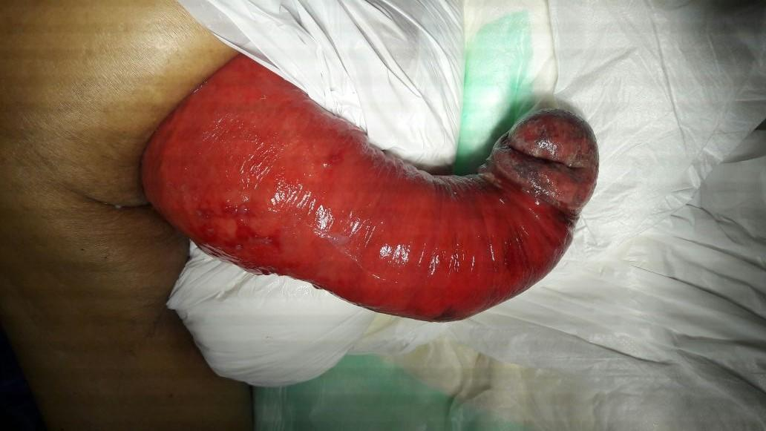
Figure 1. Incarcerated complete rectal prolapse.

It was decided to perform a perineal approach because the patient presented forced right lateral decubitus and multiple comorbidities. The Altemeier technique, a perineal rectosigmoidectomy, was chosen. In the operating room, under spinal anesthesia and with the patient in right lateral decubitus, a full-thickness circumferential incision of the rectal wall was made 2 cm from the dentate line, revealing slippage of the fornix of the Douglas pouch and a dolichosigma that was exteriorized. by manual traction. The mesorectal and mesosigmoid vessels were ligated. The redundant sigmoid colon and rectum (approximately 30 cm) were then resected. Finally, a coloanal end-to-end anastomosis was performed with absorbable suture (Fig. 2).
Recovery was favorable, with discharge on the 5th postoperative day.

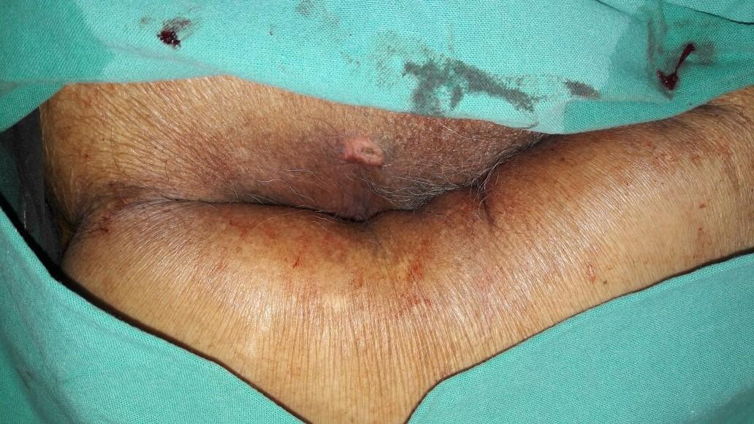
Figure 2. Postoperative outcome.

DISCUSSION
The etiological factors for the development of complete rectal prolapse are not well known. Among them we can mention chronic constipation, deep pouch of Douglas, redundant sigmoid colon and pelvic floor defects such as levator diastasis.⁴ Neurological diseases, such as senile dementia and spina bifida, are also found.² In agreement with that reported in the literature, our patient had myelomeningocele, chronic constipation, schizophrenia, deep pouch of Douglas, and pelvic floor weakness.
The clinical presentation can vary from progressive incontinence to constipation and the diagnosis is usually established by history and proctological examination.
The incarceration of rectal prolapse is rare, it occurs in less than 1% of cases, generally in patients with long-standing symptoms, as is the case of our patient who presented them for 3 years prior to surgery.
The symptoms and signs of strangulation include pain, irreducibility, edema, mucosal inflammation and red-violet coloration.¹ Our patient came to the emergency room with all these signs and symptoms, for which an urgent surgical intervention was necessary.
The curative treatment of rectal prolapse is exclusively surgical, but there is no accepted standard procedure. There are more than 100 procedures described, through the abdominal or perineal approach.⁴
We decided to perform the Altemeier procedure, one of the perineal approach alternatives. The decision was based on the fact that the patient was elderly, had a high surgical risk, and had forced right lateral decubitus. After Altemeier perineal rectosigmoidectomy, a low incidence of complications has been described, around 10-12%.³
In conclusion, the incarceration of complete rectal prolapse is an infrequent finding that requires immediate surgical intervention due to vascular compromise. The Altemeier procedure is one of the preferred options, mainly in elderly patients with significant comorbidities, due to its low morbidity and mortality.

REFERENCES
1. Zanoni AL, Bugallo F, González A, Balmaceda S, Colicigno M. Prolapso rectal. Rev Argent Coloproct 2011; 22:151-224.
2. Cannon JA. Evaluation, diagnosis, and medical management of rectal prolapse. Clin Colon Rectal Surg 2017; 30:16-21.
3. Trompetto M, Tutino R, Realis A, Novelli E, Gallo G, Clerico G. Altemeier’s procedure for complete rectal prolapse; outcome and function in 43 consecutive female patients. BMC Surgery 2019; 19:1-7.
4. Salomón M, Bugallo FG, Patrón Uriburu JC. Prolapso rectal. En: Galindo F. Cirugía Digestiva. 2009. III-383. p. 1-17.

