Case report
DOI: https://doi.org/10.46768/racp.v0i0.159

Neuroendocrine tumor of the rectum in a patient with a BRCA2 mutation (exon 23)
María Micaela Goya,¹ Mateo Santillán,¹ Sofia Akselrad,² Nicolás Avellaneda,¹ Augusto Carrié¹

Centro de Educación Médica e Investigaciones Clínicas “Norberto Quirno” (CEMIC). Ciudad de Buenos Aires, Argentina.
1Department of General Surgery, 2Department of Pathology.

The authors declare no conflicts of interest.
Nicolás Avellaneda
n.avellaneda86@gmail.com

Received: October 2021. Accepted: December 2021.
Micaela M. Goya: 0000-0003-4597-1698
Mateo Santillán: 0000-0002-9663-8601
Sofía Akselrad: 0000-0002-6757-8160
Nicolás Avellaneda: 0000-0002-6802-7125
Agusto Carrié: 0000-0003-4226-7240

ABSTRACT
In the study of genetic mutations that influence the development of neuroendocrine tumors (NETs), associations with the BRCA2 gene have been found. To date, no descriptions of BRCA2-mutated rectal NETs have been found.
Key words: Neuroendocrine Carcinoma; BCRA2; Rectum

INTRODUCTION
In the study of NETs, pathogenic germline variants were found in genes involved in DNA repair (MUTYH, CHEK2, and BRCA2), mainly in pancreatic and prostate tumors.¹
CASE
A 62-year-old woman with a history of smoking, dyslipidemia, appendiceal peritonitis, risk-reducing bilateral salpingo-oophorectomy and germline BRCA2 mutation (with multiple family history), 30 years after BRCA2 mutation diagnosis underwent colonoscopy. A 5 mm sessile polyp with central erosion was found 11 cm proximal to the anal verge and was removed by mucosal resection.
Histopathology reported a well-differentiated G2 neuroendocrine tumor with infiltration of the chorion and involved resection margin. Immunohistochemistry was positive for chromogranin, synaptophysin and Ki 67: 10% (Fig. 1).

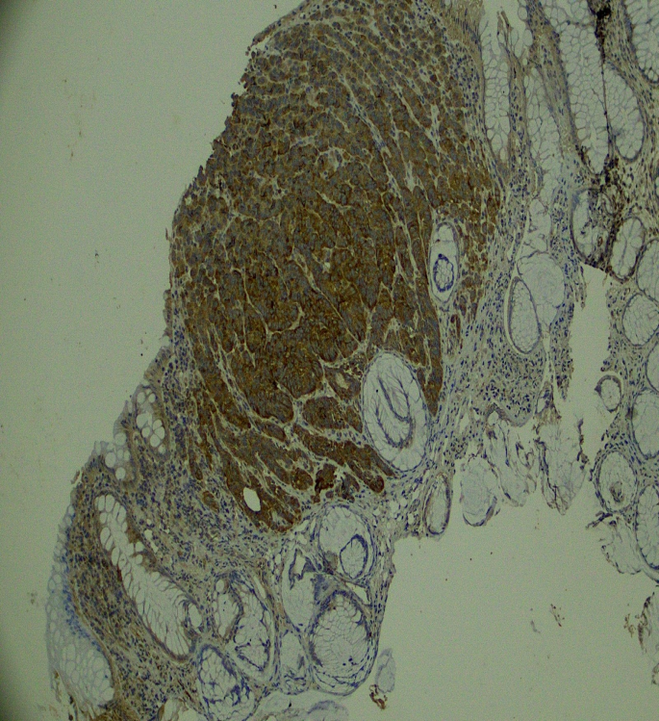

Figure 1. Colonic mucosa with a neoplastic proliferation of cells with hyperchromatic round nuclei in salt and pepper, which are arranged in rosettes.

Un PET de estadificación evidenció captación focal en la pared derecha del recto (SUV máx 5,2) y ausencia de metástasis a distancia. Por la invasión del margen profundo, se decidió realizar una resección anterior del recto por vía abdominal con anastomosis primaria (Fig. 2). La paciente evolucionó favorablemente y se otorgó el alta sanatorial al tercer día postoperatorio.
A staging PET showed focal uptake in the right rectal wall (SUV max 5.2) and no distant metastasis. Due to the invasion of the deep margin, an anterior resection of the rectum was performed (Fig. 2). The patient recovered favorably and was discharged on the third postoperative day.
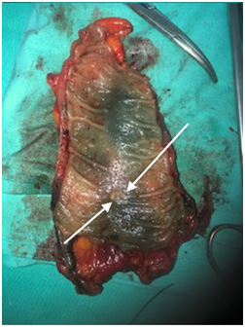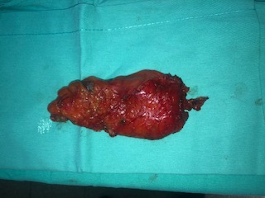

Figure 2. Surgical specimen. Note the scar from the previous endoscopic resection (arrows).

No residual tumor or vascular, lymphatic or perineural invasion was found in the surgical specimen. Lymph node resection was negative for neoplastic cells.
According to the guidelines on the management of NETs, patients with this type of lesion (less than 1 cm, completely removed, with low risk of metastasis) do not require intensive follow-up.^{2,3} However, taking into account the family history of cancer and the BRCA2 mutation, the patient will have a colonoscopy in one year.

DISCUSSION
The BRCA2 DNA repair gene mutation is a known mutation associated with ovarian and breast cancer. Many other malignancies associated with mutations in the BRCA2 gene have been found in the last ten years, including those of the pancreas and prostate.¹
In a recent meta-analysis, colorectal cancer has been associated with mutations in BRCA1 but not with BRCA2.⁴ There have been no cases of rectal NETs associated with BRCA2 mutations. We report this case in order to contribute to the available evidence to achieve a better understanding of this rare type of tumor.

REFERENCES
- Szybowska M, Mete O, Weber E, Silver J, Kim RH. Neuroendocrine neoplasms associated with germline pathogenic variants in the homologous recombination pathway. Endoc Pathol 2019;30:237-45.
- Shah MH, Goldner WS, Benson AB, Bergsland E, Blaszkowsky LS, Brock P, et al. Neuroendocrine and adrenal tumors, Version 2.2021, NCCN Clinical Practice Guidelines in Oncology. J Natl Compr Canc Netw 2021;19:839-68.
- Caplin M, Sundin A, Nillson O. ENETS Consensus Guidelines for the management of patients with digestive neuroendocrine neoplasms: colorectal neuroendocrine neoplasms. Neuroendocrinology 2012;95:88–97.
- Oh M, Alkhushaym N, Fallatah S, Althagafi A, Aljadeed A, Alsowaida Y, et al. The association of BRCA1 and BRCA2 mutations with prostate cancer risk, frequency, and mortality: A meta-analysis. Prostate 2019;79:880-95.
- Moynahan ME, Pierce AJ, Jasin M. BRCA2 is required for homology-directed repair of chromosomal breaks. Mol Cell 2001;7:263-72.

