Case report
DOI: https://doi.org/10.46768/racp.v0i0.147

Neuroendocrine carcinoma of the rectum. Infrequent presentation of an infrequent tumor
Rocío Pérez Domínguez,¹ Rosario Martiarena,² Lorena Praderio,³ Sergio Schlain⁴

Coloproctology Division and Pathological Anatomy Service, HIGA San Roque. Gonnet, Buenos Aires, Argentina.

1Staff of Coloproctology. 2General Surgery Resident. 3Head of Pathological Anatomy. 4Coloproctology Coordinator, Hospital Dr. Federico Abete, Buenos Aires, Argentina.

The authors declare no conflicts of interest.
Sergio Fernando Schlain
sergiofschlain@gmail.com
Received: July 2021. Accepted: October 2021.

Rocío Pérez Domínguez: 0000-0001-8347-0849
77
Rosario Martiarena: 0000-0002-8794-6776
Lorena Praderio: 0000-0001-8097-8022
Sergio Schlain: 0000-0002-5615-3503

ABSTRACT
Neuroendocrine carcinoma (NEC) of the rectum represents less than 1% of colorectal tumors and is the third in order of frequency after appendiceal and gastropancreatic NECs. It presents at an average age of 56 years, with a slight
predominance in men. We present a rare case of advanced NEC of the rectosigmoid colon presenting as an acute abdomen requiring emergency surgery.
Keywords: Neuroendocrine Carcinoma; Rectosigmoid Colon

INTRODUCTION

Neuroendocrine carcinoma (NEC) of the rectum is a rare variety that represents less than 1% of colorectal tumors.¹ The rectal location occupies the third place in frequency behind the appendicular and the gastropancreatic.
The presentation of neuroendocrine neoplasms (NENs) is highly variable, from small asymptomatic lesions found in screening endoscopy (40%), to larger tumors with lymphatic and/or distant metastases.
Rectal NEC occurs in relatively young patients, with a mean age at diagnosis of 56.2 years² and a slight male predominance. They are not usually associated with carcinoid syndrome since they are not serotonin producers.
We present a rare case of complicated NEC of the rectum that required emergency surgery.

CASE
A 56-year-old male patient attends the emergency room complaining of pain in the left iliac fossa and hypogastrium associated with change in the bowel habits, marked rectal syndrome and weight loss of approximately 10 kg in 3 months, symptoms that have increased in the last 2 weeks.
Physical examination: regular general condition. Abdomen: moderately distended, slightly depressible, tenderness on superficial and deep palpation, predominantly in the left iliac fossa and hypogastrium, with guarding.
Digital anorectal examination: tonic and continent sphincter with scarce fecal matter in the rectal ampulla, pain predominantly in the anterior aspect of the anal canal and traces of mucus in the glove finger. A complete colonoscopy performed 12 days ago showed multiple diverticula and a raised, elongated, friable, infiltrating-appearing lesion 12 cm from the anal margin, from which a biopsy was taken.
A non contrast computed tomography of the abdomen and pelvis performed a month ago, reported a circumferential parietal thickening of the distal sigmoid colon and rectosigmoid junction. No liver involvement (Figs. 1 and 2).

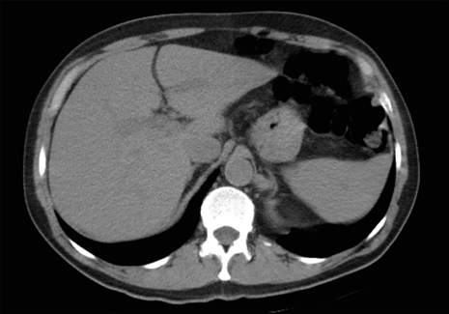
Figure 1. Abdominal computed tomography showing no focal liver lesions and absence of free fluid.

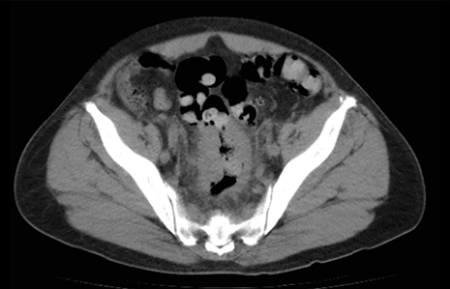

Figure 2. Circumferential parietal thickening of the distal sigmoid colon and upper rectum. Adjacent fat edema and paracolic adenopathies are also seen.

CEA: 0.67 ng/ml (N ≤5.0). Ca19-9: 2.16 U/ml (N ≤37). Given the clinical-imaging presumption of complicated rectosigmoid neoplasia, but without the histopathological report, it was decided to perform an emergency laparotomy. Abundant serosanguineous fluid, multiple nodules in both hepatic lobes, and a firm neoplasm of the distal sigmoid colon and upper rectum in an area of approximately 15 cm were found. It was firmly adhered to the rest of the sigmoid colon that was folded over the tumor and the bladder, so a low colorectal resection with end colostomy was performed.
Pathology: atypical cellular infiltration of the submucosa and muscularis propria of the rectum, consisting of atypical cells with lumpy chromatin and prominent nuclei, some with pleomorphic macronuclei. The proliferation is arranged in plates and infiltrates lymphatic vessels. There are ulcers and hypersecretory epithelium. IHC: CK-AE1/AE3: dot labeling in neoplastic cells. CD45 negative. Chromogranin A positive. Synaptophysin positive, Ki67 >75%. Diagnosis: G3 large-cell NEC, pT4-N1-Mx (Figs. 3 and 4). The patient had a torpid postoperative period, presenting on postoperative day 15 an acute hernia of the abdominal wound that required reoperation and died 35 days after the initial surgery.

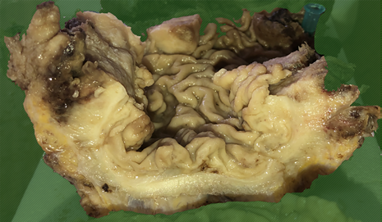
Figure 3. Resected specimen.

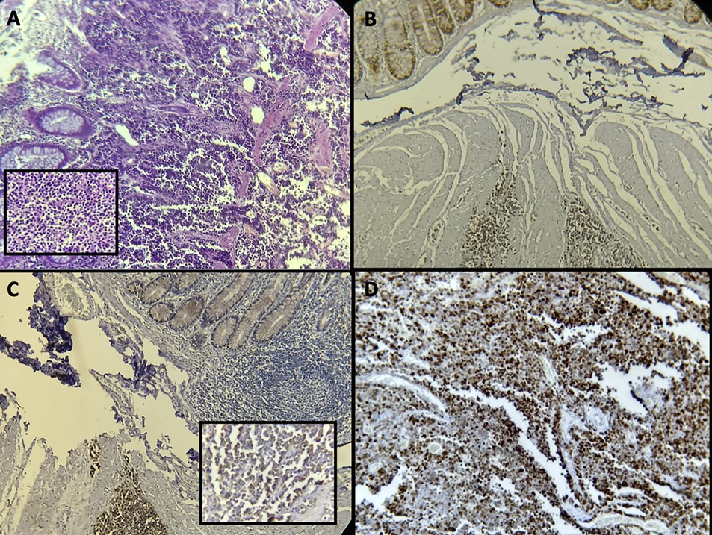

Figure 4. A) Panparietal infiltration by atypical neoplastic cells with hyperchromatic, pleomorphic and molded nuclei. B) In the lower part of the image, positive neoplastic cells for Chromogranin A are observed, confirmed by internal labeling of neuroendocrine cells from normal crypts in the upper part of the image. C) In the lower part of the image, neoplastic cells positive for Synaptophysin are observed. D) Ki67 proliferation index > 75%.

DISCUSSION
NENs are defined as tumors of epithelial origin with predominantly neuroendocrine differentiation, derived from both mucosal and submucosal cells, thus forming a heterogeneous group of infrequent pathologies, with a variable percentage of malignancy depending on the stage of diagnosis.
According to data from the Surveillance, Epidemiology and End Results (SEER) program, the incidence of rectal neuroendocrine tumors (NETs) in the United States increased from 18% in 1973 to 27% in 2004, although in Europe the rates are slightly lower, around 5-14%.²
In 2019, the World Health Organization (WHO) published a uniform classification framework for all NENs. The key feature of this new classification is the distinction between well-differentiated neuroendocrine tumors (NETs), formerly called carcinoid tumors, and poorly differentiated NECs, which share the expression of neuroendocrine markers with NETs, ​​although they are not closely related neoplasms.³
NETs are classified as G1, G2, or G3 on the basis of proliferative activity as assessed by the mitotic rate and the Ki-67 proliferative index. Mitotic rates should be expressed as the number of mitoses/2 mm2, while the Ki-67 proliferation index is determined by counting at least 500 cells in the regions of highest labeling, which are identified by magnification.
In this new classification, the concept of G3 NETs (well-differentiated tumors with high proliferation) was integrated into the WHO classification of well-differentiated NENs, leaving the definition of NECs to neoplasms with poorly differentiated morphology.⁵ The new classification avoids confusion between these 2 clinically and molecularly distinct entities.
This distinction is important when choosing platinum-based chemotherapy, since NECs have a good response, while G3 NETs have a poor response.⁴
NETs of the colon and rectum are either of enterochromaffin (EC) cell type or large (L) cell type. EC cell-derived NETs are found primarily in the right colon and are characterized by serotonin production. In contrast, L cell tumors occur predominantly in the colon and rectum and are characterized by the production of glucagon-like peptide and PP/PYY. In both cases, the Ki67 and the mitotic count are usually low, belonging to grade G1.
NECs are poorly differentiated, high-grade neoplasms composed of tumor cells that express neuroendocrine markers such as chromogranin A and synaptophysin, present marked cell atypia, frequent necrosis, and high proliferative activity. These are grade G3 tumors that are further subdivided into large and small cell carcinomas. L cell tumors occur mainly in the right colon and represent 75% of colorectal NECs. They present a solid or undifferentiated growth pattern, with areas of necrosis and very atypical vesicular nuclei. The mitotic count is very high, as is the Ki67. Immunohistochemistry is positive for chromogranin A, synaptophysin, and CD56, however, it lacks the production of specific hormones. Small cell NECs represent 25% of colorectal NNEs, present a diffuse growth pattern, with small cells with scant cytoplasm and thick chromatin nuclei. They present high mitotic activity and Ki67 index. This morphological variety presents a diffuse possibility of staining for synaptophysin, while chromogranin can be negative. Likewise, the aberrant expression of p53 and Rb are common events in the generation of these types of tumors.
Most rectal lesions (75-85%) are localized at the time of diagnosis. Distant metastases are rare (2-8%), with bone, lymph nodes, and liver being the most frequently affected sites. In the latest SEER series dating from 1973 to 2004, 4% had regional and 5% distant metastases.²
Metastatic disease, associated with tumors larger than 2 cm, can present as abdominal pain in the right upper quadrant associated with hepatomegaly, hydronephrosis, lethargy, anorexia, or generalized symptoms of carcinomatosis. Bowel obstruction from rectal tumors is rare, but can occur with rectosigmoid/sigmoid lesions or advanced intra-abdominal disease.
Regarding diagnosis, rectal lesions are generally an endoscopic finding located in the submucosa. They are small, sessile, rounded, solitary polypoid tumors, with a yellowish and smooth appearance, covered with mucosa. Approximately 80% are <10 mm, 15% from 11 to 20 mm, and 5% >20 mm.⁶
The most advanced lesions are larger and usually present as ulcerated masses with raised mucosal borders, similar to classic carcinomas. Eighty percent of rectal NENs can be treated endoscopically by submucosal dissection, as long as they are tumors <10 mm, which have low risk of metastasis (regional lymphatic 3% and distant 1.6 %) and good prognosis.
Local resection with standard oncological criteria is appropriate only for small tumors. In tumors up to 20 mm, the risk of metastasis increases to 66%. In lesions >20 mm, which are frequently associated with muscle infiltration, regional lymph node invasion was found in 73% of patients and distant metastasis in 100%, so these tumors should be treated similarly to adenocarcinomas of the rectum, with radical resection and total mesorectal excision,⁷ with or without preservation of sphincters depending on the distance to the anal margin.
Platinum-based chemotherapy is often used as a therapeutic strategy with a response rate of 42%,⁸ although an oncospecific treatment guideline is not yet available.
For patients with metastatic NENs, resection of the primary tumor is appropriate, although there is no clear survival benefit. There are not enough data for the management of liver metastases from colorectal NETs, so the guidelines for small intestine NETs are followed, for which there is more solid evidence. Patients with G3 colorectal NEC have a poorer overall survival than those with NENs of all other gastrointestinal organs. The median survival of patients with NEC of the colon and rectum is 5 to 11 months. Survival rates at one year range between 10 and 15%.9
The presentation of the tumor in this clinical case is rare and advanced. A bibliographic update was carried out and the new WHO classification of neuroendocrine tumors is presented.

REFERENCES
1. Smith JD, Reidy DL, Goodman KA, Shia J, Nash GM. A retrospective review of 126 high-grade neuroendocrine carcinomas of the colon and rectum. Ann Surg Oncol; 21:2956-62.
2. Caplin M, Sundin A, Nillson O, Baum RP, Klose KJ, Kelestimur F et al. Barcelona Consensus Conference participants. ENETS Consensus Guidelines for the management of patients with digestive neuroendocrine neoplasms: colorectal neuroendocrine neoplasms. Neuroendocrinology 2012; 95:88-97.
3. Rindi G, Komminoth P, Scoazec JY, Shia J. Colorectal neuroendocrine neoplasms. The 2019 WHO classification of digestive system tumours. 5th ed. 2019. p 188-91.
4. Assarzadegan N, Montgomery E. What is New in the 2019 World Health Organization (WHO) classification of tumors of the digestive system: review of selected updates on neuroendocrine neoplasms, appendiceal tumors, and molecular testing. Arch Pathol Lab Med 2021; 145:664-77.
5. La Rosa S. Challenges in high-grade neuroendocrine neoplasms and mixed neuroendocrine/non-neuroendocrine neoplasms. Endocr Pathol 2021; 32:245-57.
6. Bertani E, Ravizza D, Milione M, Massironi S, Grana CM, Zerini D et al. Neuroendocrine neoplasms of rectum: A management update. Cancer Treat Rev 2018; 66:45-55.
7. Mestier L, Brixi H, Gincul R, Ponchon T, Cadiot G. Updating the management of patients with rectal neuroendocrine tumors. Endoscopy 2013; 45:1039-46.
8. Yoshida T, Kamimura K, Hosaka K, Doumori K, Oka H, Sato A, et al. Colorectal neuroendocrine carcinoma: A case report and review of the literature. World J Clin Cases 2019; 7:1865-75.
9. Bernick PE, Klimstra DS, Shia J, Minsky B, Saltz L, Shi W et al. Neuroendocrine carcinomas of the colon and rectum. Dis Colon Rectum 2004; 47:163-69.

COMENTARIO
La actualización bibliográfica de las neoplasias neuroendocrinas (NNE) colorrectales es importante ya que son tumorespocofrecuentes.Larealizacióndepesquisaparaladetecciónprecozdelcáncercolorrectal(adenocarcinoma),incrementó su diagnóstico.
Las NNE colorrectales son de lento crecimiento. La gran mayoría son lesiones pequeñas, no mayores a 2 cm, de aspectopolipoide,limitadasalamucosaysubmucosa,biendiferenciadas,decomportamientopocoagresivoyasintomáticas, siendo habitualmente un hallazgo endoscópico.
El80%sonlocalizadas,perodebenrealizarseestudiosparaevaluarelgradohistológicoyelíndicedeproliferación celular,paradeterminarelgradodeagresividad.
El mejor indicador pronóstico es el tamaño tumoral, así como el grado de profundidad de invasión tisular y la presencia o no de adenopatías regionales o metástasis a distancia. Si la lesión es menor a 1 cm puede indicarse la resección endoscópica, pero si es mayor a 2 cm se aconseja realizar la resección quirúrgica, ya que presenta mayor riesgo de invasión linfática.
La gran mayoría de los tumores neuroendocrinos colorrectales son pequeños y de buen pronóstico. Pero menos frecuentemente nos encontramos casos como el presentado en este artículo, que presentan transformación carcinomatosa, con gran invasión y agresividad locoregional y muy mal pronóstico. En estos casos el tratamiento quirúrgico es para paliar los síntomas obstructivos o hemorrágicos, ya que no mejora el pronóstico de la enfermedad.
El mejor tratamiento es la prevención y el diagnóstico precoz, por tal motivo es indispensable la difusión de la existencia de estas patologías para información de la población y poder realizar precozmente mayor número de estudios diagnósticos. Es fundamental difundir la necesidad de realizar estudios videocolonoscópicos periódicamente, para la detección precoz de los tumores del colon.
Felicito a los autores por la presentación, actualización bibliográfica y manejo clínico-quirúrgico del caso.

Marcelo Pollastri
Hospital Privado de Rosario. Santa Fe, Argentina.

